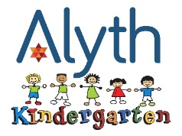

Autumn Term 2025
Thursday 4 September – Friday 24 October
Half Term: 27 October – Friday 31 October
Monday 3 November – Friday 19 December

Kindergarten closes for Rosh Hashanah on Tues 23 Sept and Wed 24 Sept
Kindergarten closes for Yom Kippur on Thursday 2 October
Kindergarten closes for Sukkot on Tuesday 7 October
Kindergarten closes for Simchat Torah on Tues 14 October
22nd September (Rosh Hashana), 1st October (Kol Nidre), 6th October (Erev Sukkot), 13TH October (Erev Simchat Torah) – No extended day

Spring Term 2026
Tuesday 6 January – Friday 13 February
Half Term: Monday 16 February – Friday 20 February
Monday 23 February – Friday 27 March

Summer Term 2026
Monday 13 April – Thursday 21 May
Half Term: Monday 25 May – Friday 29 May
Monday 1 June – Thursday 16 July

Kindergarten closes on Monday 4th May: Bank Holiday & on Friday 22 May for Shavuot
21st May (Erev Shavuot) & 16th July (last day of term) – no extended day

