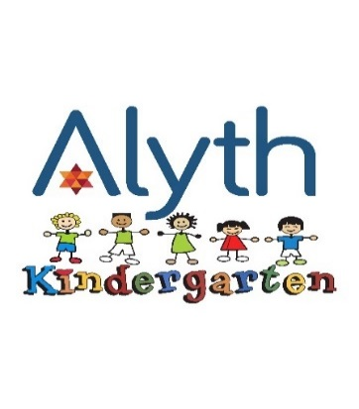
4.3 Registration form

REGISTRATION FORM

I wish to apply for the enrolment of my son / daughter for the autumn or spring term

(Please tick box) starting ……………………………………(Month) 20………(Year)

Child’s surname (Block Letters)…………………………………………………….....

Date of Birth…………………………………………………………………………………

First Name (s)…………………………………………………………………………………

Address………………………………………………………………………………………….

Tel No………………………………………………………………………………………………

Parent 1 Name …………………………………………………………………………………

Parent 1 Mobile Number ………………………………………………………………….

Parent 1 Home Number ……………………………………………………………………

Parent 1 Email ………………………………………………………………………………….

Address if different from above…………………………………………………………

Parent 2 Name:………………………………………………………………………………….

Parent 2 Mobile Number……………………………………………………………………

Parent 2 Home Number………………………………………………………………………

Parent 2 Email …………………………………………………………………………………..

Address if different from above………………………………………………………….

……………………………………………………………………………………………………………

Members of Alyth Synagogue pay around £800 per academic year less than non-members and enjoy all the benefits of one of Britain’s most family friendly synagogues.

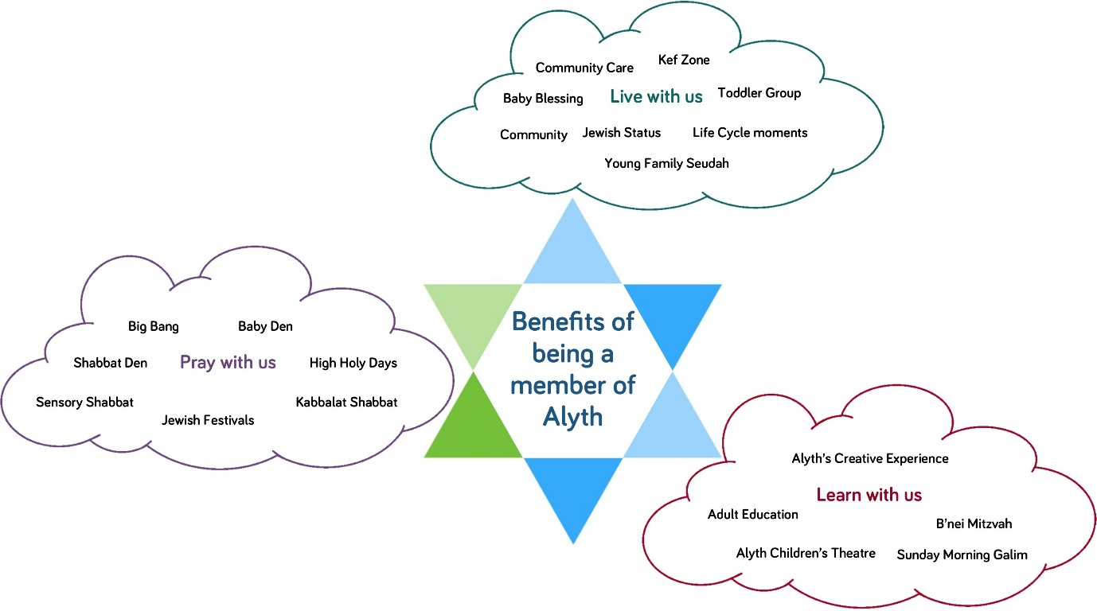

I’m already a member of Alyth Synagogue

Would you like us to contact you to become a member of Alyth Synagogue?

If you are a member of another Synagogue, which one?

………………………………………………………….

I enclose a non-refundable enrolment fee of £100 Members of Alyth Synagogue/£150.00 Non-Members (cheques made payable to NWRS Kindergarten Account)
You will be required to pay a deposit of £500, once your place at the kindergarten has been confirmed.
As stated in the Alyth Kindergarten Acceptance Letter and the Alyth Kindergarten Terms and Conditions, a deposit of £500 (cash or cheque only – bank details will be provided) will only be refundable at the end of the summer term in K2 depending on the following:-
- Your child has completed K1 and K2. This equates to six terms at the Kindergarten, or five terms if your child started in January or 3 academic years if repeating in K1. Please note, any parents wishing to remove their child before the end of the second year will not have their deposit refunded.
- You have accepted a place for your child (classes K1 or K2) but due to unforeseen circumstances are unable to take up the place before the academic year commences (September or January) and we are able to fill your child’s place before the academic year starts. NB If we are unable to fill your place we are not able to return your £500.00 deposit.
- You have given a term’s notice in writing before withdrawing your child from the Kindergarten otherwise a full term’s fees will be payable.

Signature of Parent or Guardian………………………………………………………..

Date:………………………………………………………………………………………………….

