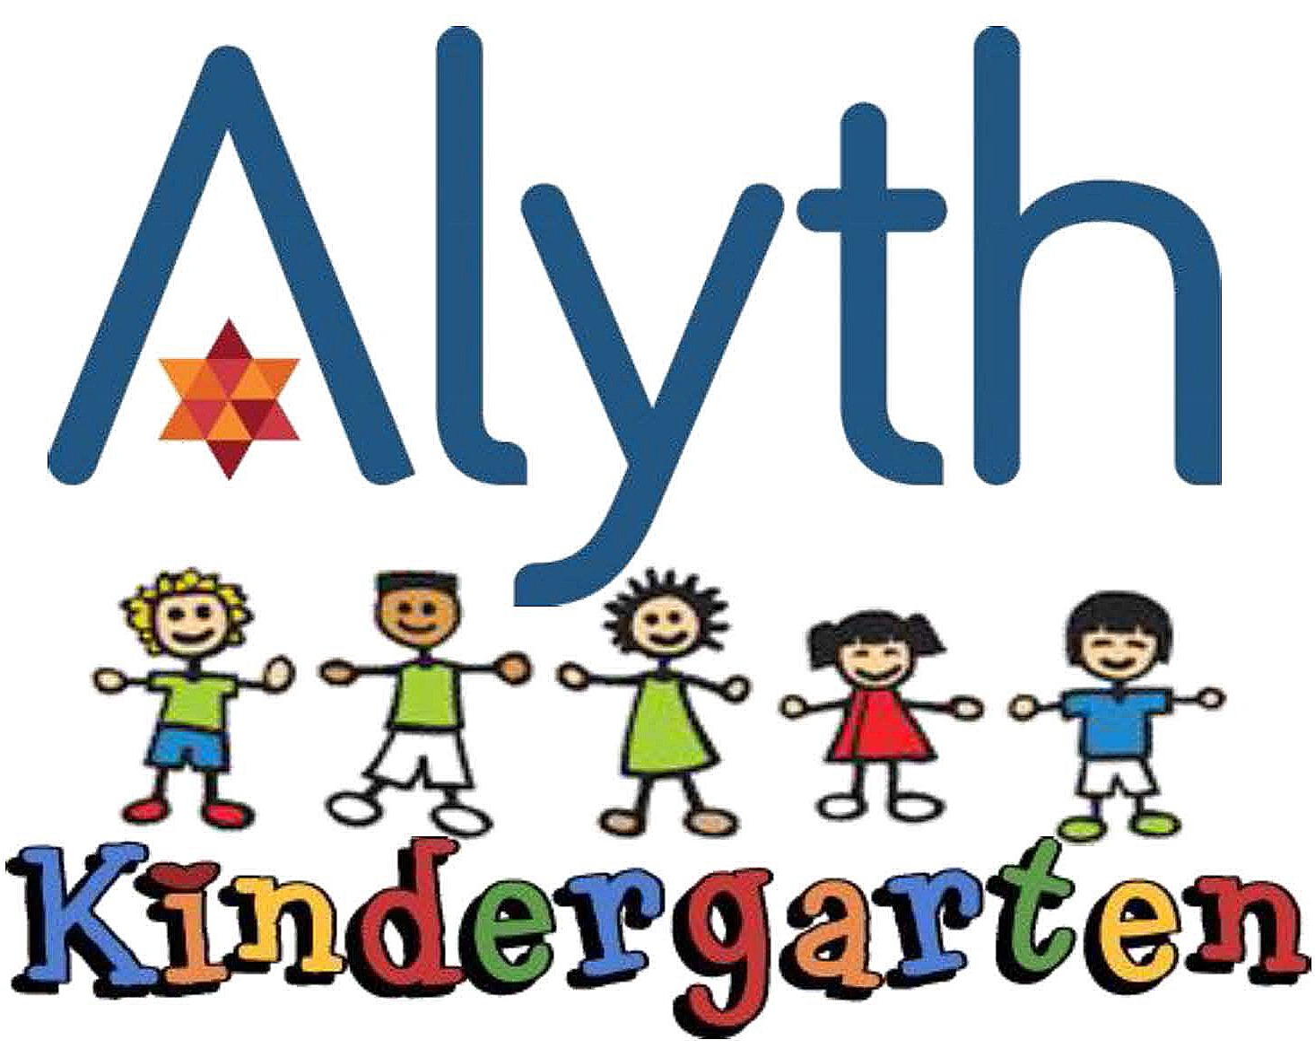

PHOTOGRAPHS
Amended July 2018

Alyth Kindergarten complies with the Data Protection Act 1998 and the new GDPR regulations (May 2018) and we are registered with the ICO, Information Commissioner’s Office.

We take photos or videos using ‘Tapestry’ (an on line learning journal) of the children participating in a variety of activities. These are used for the Kindergarten weekly Newsletter, circulated via email, for wall displays in the Kindergarten and the Synagogue. They form an essential part of the cycle of observation, assessment, evaluation and planning. Photos are included in Transition Reports to Primary Schools or other settings. We also take photos on Kindergarten visits off site and during Kindergarten Kabbalat Shabbat and festival parties and various other events.

The photos will not be displayed anywhere else without separate parental consent.

All photos at Alyth Kindergarten are taken by Kindergarten staff with the kindergarten iPads. Teachers do not use mobile phones to take photos at kindergarten (see our Safeguarding, Mobile Phone Policy).

Parents may take photos of their own children at concerts and Kindergarten Kabbalat Shabbat however, these images must not be uploaded onto any social network site.

Please be aware that any photos taken of Alyth Kindergarten children participating in Alyth Kindergarten activity onsite or offsite whilst under our auspices, must not be posted on social media websites.

Victoria Alter
Head Teacher
--------------------------------------------------------------------------------------------------------

Photograph Permission Slip

I give permission for my child …………………………………………………………….
to be photographed in accordance with above policy.

Signed: ……………………………………………………………………………………..

Name: ……………………………………………………………………………………..

Date: ……………………………………..

